DOWSON BURGER STATION
Executive Summary
Jan 2024 – Dec 2025 | Sales and profit at a glance
$43,798  Total sales | $26,051  Gross profit | 59.5%  Margin | 2,944  Orders | 5,940  Burgers sold | $14.88  Average profit per order

THE BOTTOM LINE
- Sales are growing: up 15.6% from 2024 to 2025.
- Profit is steady: about 59.5% of every $1 sold is left after burger costs.
- Weekends are the busiest time: 56% of sales come on Fri–Sun.
- One customer = 22% of all sales. This needs checking.
- The Tuesday 10% discount costs money and does not seem to bring in more customers.

WHAT WE FOUND
1 Number of Order and Profit
- Day in highest number of order: Saturday (604 orders)
- Highest gross profit per burger: Double Smash (L-6.4, M-5.2)
- Lowest gross profit per burger: Classic Cheese (L-4.21, M-3.32)

2 Segment-wise / Area-wise Highest Preference
- 37.75% Family segment like Classic Cheeseburger
- 30.32% Night Shift Regular segment like Double Smash
- 27.44% Office Worker segment like Classic Cheeseburger
- 25.17% Student segment like Garden Veggie
- 26.10% Walk-in Customer segment like Classic Cheeseburger
- Campus Area, Industrial Park, North Subrub, Riverside these 4 area’s preferred burger is Double Smash
- Downtown – Crispy Chicken
- Old-town – Inferno Hot Chicken

3 Sales are growing
- 2024 sales: $20,317
- 2025 sales: $23,480 (+15.6%)
- Best quarter: Q4 2025 ($6,153)
- Profit margin did not change (about 59.5% both years)

4 Weekends and mealtimes are the busiest
- Fri–Sun = 56% of all sales
- Saturday: $89 per day. Monday: $39 per day
- Lunch (12 pm hour) = 15% of sales
- Dinner (6–9 pm) = 34% of sales

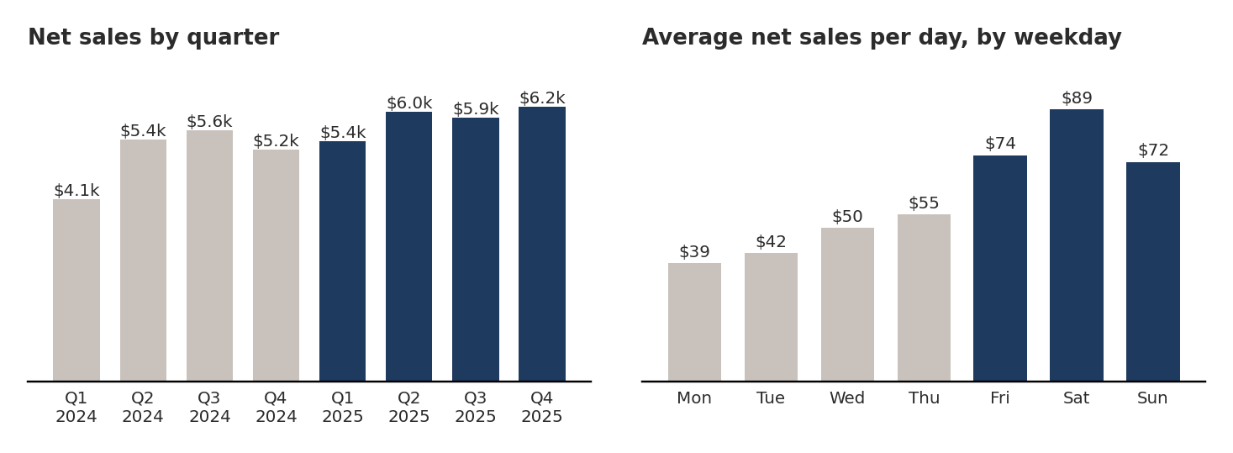
5 The best-seller is not the best earner
- Double Smash: 27.6% of sales, but the lowest profit margin (56.4%)
- Garden Veggie: only 13.1% of sales, but the highest margin (65.2%)
- Medium burgers: 60% of burgers sold, and a better margin than Large (60.7% vs 58.1%)

6 One customer = 22% of all sales
- Customer C079 (Fatima Brown): 653 orders, $9,731 in sales
- Most orders placed between 10 pm and 1 am
- The next-biggest customer is under 3% of sales
- Walk-in guests (no details recorded): another 35% of sales

7 The Tuesday 10% discount is not working
- Discount cost: $490 (82% of all discounts given)
- Tuesday margin: 55.9%. Other days: about 60%
- Tuesday sales: $42 per day. Wednesday: $50. Thursday: $55
- No “before” data exists, so this is a warning sign, not proof

8 Families spend the most per order
- Family order: $29.74. Other groups: $13–$15
- But families placed only 213 orders in total
- Dine-in = 46% of sales, with $15.43 per order (delivery: $13.92)

BURGER-BY-BURGER RESULTS
Red = lowest margin. Green = highest margin.
Burger | Sold | Sales | Share of sales | Profit margin
Double Smash | 1,205 | $12,108 | 27.6% | 56.4%
Classic Cheeseburger | 1,484 | $9,031 | 20.6% | 60.3%
Crispy Chicken | 1,255 | $8,606 | 19.6% | 60.1%
Inferno Hot Chicken | 1,092 | $8,324 | 19.0% | 58.6%
Garden Veggie | 904 | $5,729 | 13.1% | 65.2%
Total | 5,940 | $43,798 | 100% | 59.5%

WHAT TO DO NEXT
- Need to replace the Tuesday 10% discount with a bundle or upsell offer, and test it.
- Promote Garden Veggie and Medium sizes. They earn more per sale.
- Review Double Smash Large pricing. It costs $5.10 and sells at $11.50. About $12.75 would give a 60% margin.
- Collect walk-in customer details (sign-up, app, digital receipt).
- Plan staff and stock for Fri–Sun and the lunch and dinner rush. Try family bundles.

HERE IMPORTANT
- Sales = money collected after discounts. Discounts given: $594 (1.3%).
- Profit = sales minus burger cost ($17,747). Rent, wages and other expenses are not included.
- Profit margin = profit ÷ sales.
- The dashboard card “Total Transactions = 4,162” counts order lines. Real orders = 2,944. So $14.88 per order is correct. Suggest renaming that card.

